**ShopNest Store**

**Introduction:**

Welcome to the ShopNest Store Performance Dashboard Report. This report provides a comprehensive analysis of key metrics and trends to understand the store's performance across various dimensions. By leveraging data-driven insights, this dashboard aims to uncover valuable information on sales trends, product performance, customer behavior, and operational efficiency.

The dashboard explores critical areas such as revenue analysis over time, state-wise sales comparisons, product rating insights, and seasonal sales patterns. These insights are crucial for making informed decisions to enhance customer satisfaction, optimize inventory management, and drive business growth.

Through visually appealing charts and detailed analysis, this report aims to guide strategic initiatives and operational improvements that align with ShopNest's goals of delivering exceptional customer value and operational excellence.

Top Categories by Total Price:

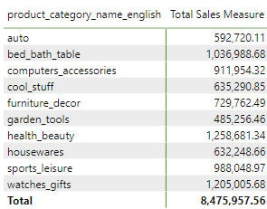The table provides an insightful breakdown of total sales figures across various product categories, revealing significant trends and disparities. The "health_beauty" category stands out as the top performer, indicating a high consumer demand and potentially a lucrative market segment. Similarly, "watches_gifts" and "bed_bath_table" also demonstrate strong sales, suggesting these categories are highly popular among consumers, possibly due to their relevance in daily life and gift-giving occasions.

Conversely, "garden_tools" exhibits the lowest sales, which might reflect a niche market or seasonal fluctuations affecting consumer purchasing behavior. The substantial difference in sales between the top and bottom categories highlights the diverse consumer preferences and market dynamics within different product segments.

The overall total sales of $8,475,957.56 underscore the significant revenue generated across all categories, providing a comprehensive overview of the business's performance. This data can guide strategic decisions, such as inventory management, marketing focus, and resource allocation, to enhance sales in underperforming categories and sustain growth in high-performing ones.

Moreover, analyzing this sales distribution can uncover potential areas for expansion or improvement, helping the business to better cater to consumer needs and preferences. Understanding these insights is crucial for driving sales strategies, optimizing product offerings, and ultimately boosting overall profitability.

**Delayed Orders Analysis:**

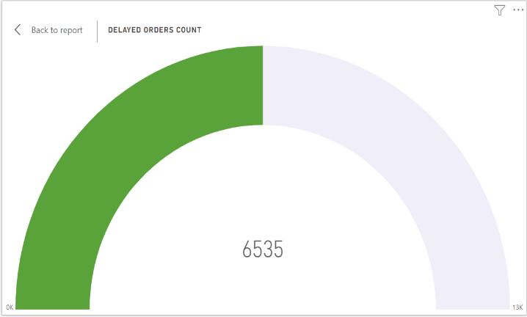The visualization presents the count of delayed orders, displayed in a semi-circular gauge format. The total number of delayed orders is prominently shown at the center, which is 6,535. The gauge visually represents the proportion of delayed orders against a defined benchmark or maximum value of 13,000, as indicated at the far right end of the gauge.

The green segment of the gauge illustrates the count of delayed orders, while the light purple segment represents the remaining capacity up to the maximum benchmark. This visual clearly indicates that approximately half of the orders have been delayed, as the green segment covers nearly half of the gauge.

Key insights from this visualization include:

* The significant number of delayed orders (6,535) suggests potential issues in the supply chain, logistics, or other operational areas.
* The gauge format provides an immediate visual indication that delayed orders are a critical concern, occupying a substantial portion of the total capacity.
* Addressing the reasons for these delays could improve overall efficiency, customer satisfaction, and potentially reduce costs associated with late deliveries.

By closely monitoring this metric, the business can implement strategies to reduce delays, optimize processes, and enhance overall performance. Understanding and mitigating the causes of these delays is crucial for maintaining customer trust and ensuring timely deliveries.

**Monthly Comparison of Delayed and On-Time Orders:**

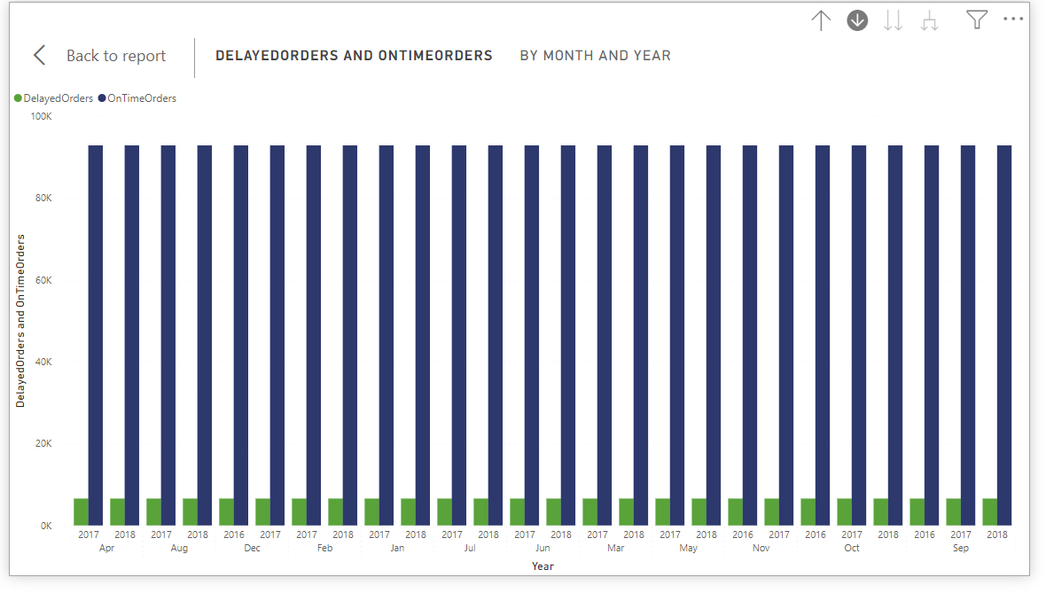The bar chart visualizes the monthly comparison of delayed orders (in green) versus on-time orders (in blue) over an extended period, broken down by month and year. This comparison helps identify trends and patterns in order delivery performance.

Key insights from this visualization include:

* The blue bars, representing on-time orders, consistently surpass the green bars, which depict delayed orders, across all months and years. This indicates a generally good performance in meeting delivery timelines.
* Despite the overall positive trend, there is a noticeable presence of delayed orders every month. This suggests there is still room for improvement in reducing delays.
* The visual makes it easy to spot months with relatively higher delays, prompting further investigation into potential causes such as seasonal demand, supply chain issues, or other operational challenges.

The drillthrough cross-report feature can be used to provide detailed analysis by allowing users to click on specific data points in the visual to drill down into more granular data. This could include looking into specific product categories, regions, or time periods where delays are more frequent. Utilizing this feature enables a deeper understanding of the factors contributing to delayed deliveries and helps in formulating targeted strategies to address these issues.

By leveraging this visualization and the drillthrough feature, businesses can better monitor delivery performance, identify problem areas, and implement measures to enhance overall efficiency and customer satisfaction.

**Payment Method Analysis:**

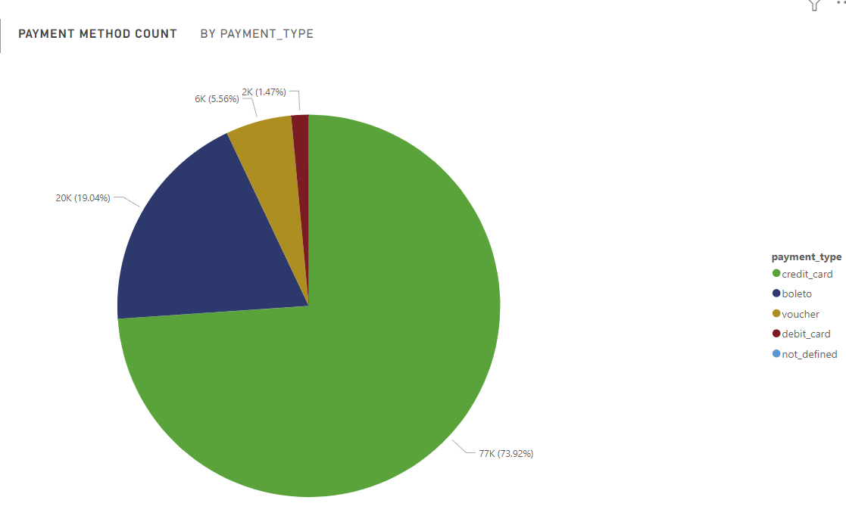The pie chart represents the distribution of various payment methods used by customers. The chart segments indicate the proportion of transactions made using each payment method, providing a clear visual comparison.

Key insights from this visualization include:

* **Credit Card (73.92%)**: The majority of transactions, amounting to 77,000, are made using credit cards. This dominance suggests that customers prefer credit cards for their purchases, possibly due to convenience, rewards programs, or credit availability.
* **Boleto (19.4%)**: The second most used payment method is "boleto," with 20,000 transactions. This method is particularly popular in some regions and may reflect cultural or regional preferences.
* **Voucher (5.56%)**: Vouchers account for 6,000 transactions, indicating a smaller yet notable segment of the market. This could include gift cards, promotional vouchers, or other types of prepaid cards.
* **Debit Card (1.47%)**: The least used method is debit cards, with only 2,000 transactions. This might be due to the lower prevalence of debit cards among the customer base or a preference for credit-based payment options.

Understanding the distribution of payment methods helps businesses tailor their payment options to meet customer preferences, enhance the checkout experience, and potentially increase sales. For instance, emphasizing the most popular methods in marketing materials or offering incentives for less used methods could balance the usage distribution.

Moreover, this analysis can guide decisions about payment gateway partnerships, fraud prevention measures, and financial planning. By closely monitoring and adapting to payment trends, businesses can improve transaction efficiency and customer satisfaction.

**Product Rating Analysis:**

Top 10 Rating by category Bottom 10 Rating by category

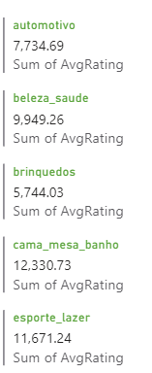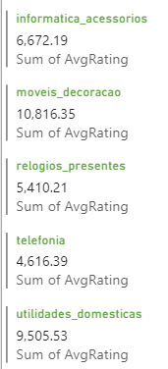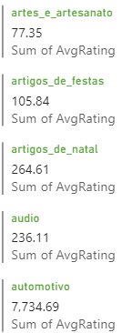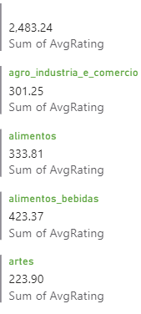

**State-wise Sales Analysis:**

**Bottom 5 sales by states** Top 5 sales by states

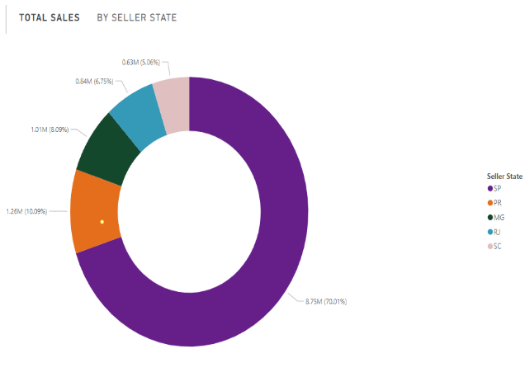

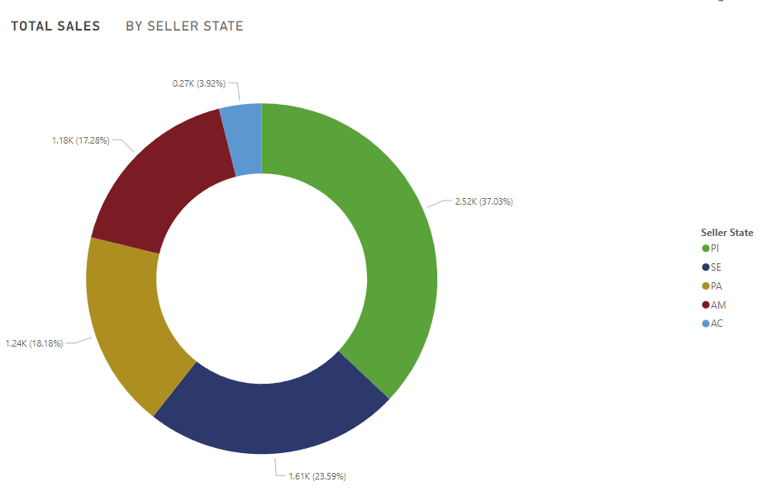

**Seasonal Sales Patterns:**

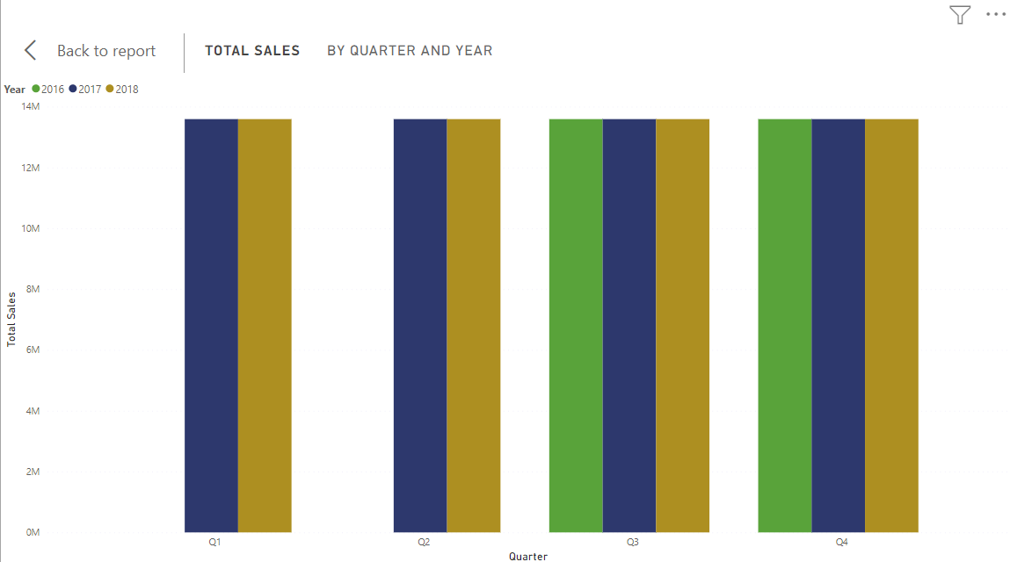The bar chart represents the total sales by quarter for the years 2016, 2017, and 2018. Each quarter is compared across the three years, providing a clear view of seasonal sales patterns and trends.

Key insights from this visualization include:

1. **Consistent Sales Across Quarters:**
   * Sales figures are relatively consistent across all quarters for each year.
   * This suggests a stable sales performance throughout the year without significant seasonal fluctuations.
2. **Growth Over the Years:**
   * There is a noticeable increase in sales from 2016 to 2018 across all quarters.
   * This indicates overall growth in the store's sales performance year over year.
3. **Quarterly Comparisons:**
   * **Q1:** The sales in Q1 show a steady increase from 2016 to 2018, with 2018 having the highest sales.
   * **Q2:** Similarly, Q2 sales grow steadily, with 2018 outperforming the previous years.
   * **Q3:** Q3 shows a notable increase in sales in 2017 compared to 2016, and a slight increase from 2017 to 2018.
   * **Q4:** Q4 also demonstrates a consistent increase in sales each year, with 2018 leading.
4. **Peak Performance in 2018:**
   * The highest sales figures are observed in 2018 across all quarters, highlighting a peak performance year for the store.
5. **Strategic Implications:**
   * The stable sales performance across all quarters indicates that the store's sales are not heavily dependent on specific seasons.
   * The consistent growth suggests that the store's marketing, product offerings, and customer acquisition strategies are effectively driving sales.
6. **Future Planning:**
   * Understanding these trends allows the store to plan inventory, marketing campaigns, and staffing needs more accurately.
   * By maintaining the strategies that have driven growth and identifying areas for improvement, the store can aim for continued growth in the coming years.

This analysis highlights the importance of quarterly monitoring and year-over-year comparisons to understand and leverage seasonal sales patterns. By recognizing these trends, ShopNest can ensure sustained growth and optimize its operations throughout the year.

**Revenue Analysis:**

The line chart illustrates the total revenue growth of ShopNest Store over the period from 2016 to 2018. The graph highlights a strong upward trajectory, with revenue rising sharply from 2016 to 2017 and maintaining a steady increase through 2018. This significant growth suggests that ShopNest has successfully implemented strategies in market expansion, customer acquisition, and product offerings.

Key insights from this visualization include:

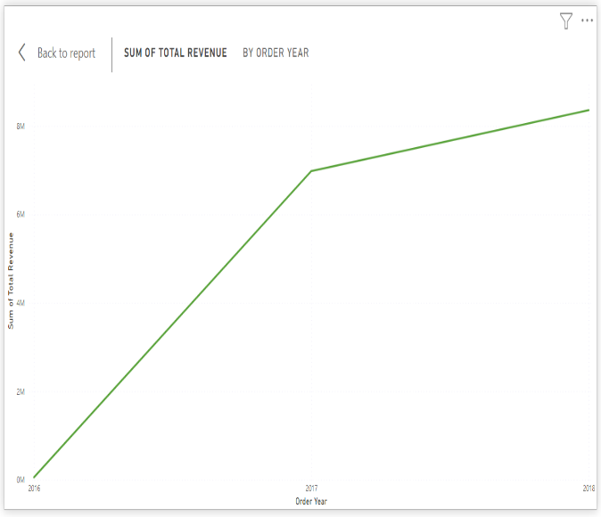**2016 to 2017 Spike:** The revenue spike from 2016 to 2017 is particularly notable, indicating a period of rapid growth and possibly reflecting successful marketing campaigns or the introduction of popular new products. This period likely saw substantial customer acquisition and market penetration efforts paying off.

**Steady Growth in 2018:** The continued growth in 2018 shows sustained performance and suggests that the store has effectively retained customers while attracting new ones. This steady increase points to ongoing operational efficiency and strong customer loyalty.

**Strategic Implementation:** The consistent upward trend underscores ShopNest's increasing market presence. This could be attributed to strategic decisions in inventory management, pricing strategies, and enhanced customer service, which collectively drive higher sales.

**Future Prospects:** To gain a more comprehensive understanding of this growth, further analysis could include a breakdown of revenue by month to identify seasonal trends, an examination of top-performing product categories, and an assessment of customer demographics. Additionally, understanding the impact of external factors, such as economic conditions or industry trends, would provide deeper insights into the revenue patterns observed.

Understanding the factors contributing to this revenue growth is crucial for strategic planning. By analyzing these trends, ShopNest can continue to refine its business strategies, capitalize on market opportunities, and mitigate potential risks, ensuring sustained growth and profitability in the future. This analysis forms a crucial part of strategic planning and decision-making for future growth and sustainability.

**Conclusion:**

In conclusion, the ShopNest Store Performance Dashboard Report provides valuable insights into various aspects of the store’s operations, including sales trends, product performance, customer behavior, and operational efficiency. The data-driven analysis presented in this report highlights several key findings:

1. **Consistent Sales Performance:**
   * Sales across all quarters have shown consistency with a noticeable year-over-year growth from 2016 to 2018.
   * This indicates a stable and growing market presence, suggesting effective marketing strategies and strong customer retention.
2. **Top Performing Categories:**
   * Categories such as "health_beauty," "watches_gifts," and "bed_bath_table" have emerged as top performers, indicating high consumer demand and potential areas for further investment.
   * Conversely, the lower performance of the "garden_tools" category suggests an opportunity to investigate and address potential issues.
3. **Operational Challenges:**
   * The significant number of delayed orders (6,535) highlights potential inefficiencies in the supply chain or logistics that need to be addressed to improve overall customer satisfaction and reduce operational costs.
4. **Payment Method Preferences:**
   * The dominance of credit card transactions (73.92%) suggests a customer preference for this payment method, potentially due to convenience and reward programs.
   * Understanding these preferences can help in optimizing the checkout process and offering tailored promotions.
5. **State-wise Sales Insights:**
   * Analyzing state-wise sales data can guide regional marketing strategies, helping to boost performance in underperforming areas and capitalize on strong markets.
6. **Revenue Growth:**
   * The steady revenue growth from 2016 to 2018 reflects successful strategic initiatives in market expansion, product offerings, and customer acquisition.

**Recommendations:**

Based on the insights from this report, the following recommendations are proposed to drive further growth and operational efficiency:

1. **Enhance Supply Chain Efficiency:**
   * Investigate the root causes of delayed orders and implement strategies to optimize the supply chain and logistics processes.
2. **Focus on High-Performing Categories:**
   * Invest in marketing and inventory for high-performing categories while exploring ways to boost sales in underperforming segments.
3. **Optimize Payment Options:**
   * Enhance the checkout experience by emphasizing popular payment methods and offering incentives for lesser-used options to balance distribution.
4. **Leverage Regional Insights:**
   * Tailor marketing and promotional strategies based on state-wise sales data to address regional preferences and boost overall sales.
5. **Monitor and Maintain Growth:**
   * Continue to monitor sales trends and revenue growth, ensuring that successful strategies are maintained and areas for improvement are identified.

**Future Directions:**

To further enhance the performance of ShopNest Store, consider the following future directions:

* Conduct detailed customer satisfaction surveys to gain deeper insights into customer preferences and areas for improvement.
* Implement advanced data analytics and machine learning techniques to predict sales trends and optimize inventory management.
* Explore new market segments and expand product offerings to cater to diverse customer needs.

By following these recommendations and continuously leveraging data-driven insights, ShopNest Store can achieve sustained growth, improved operational efficiency, and enhanced customer satisfaction.